WHEN: Saturday, October 14, 2017, from 9:00 a.m to 12:00 noon (please
arrive early to check-in)
WHERE: Alcuin School, Wyly Performance Space
6144 Churchill Way, Dallas, 75230
WHAT:

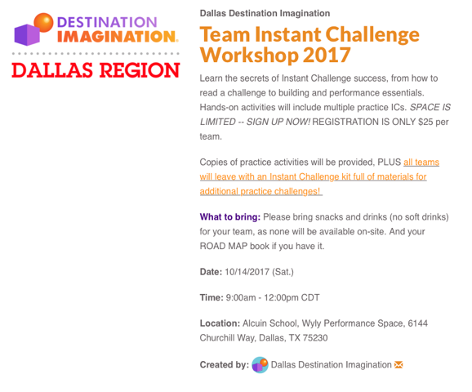
Link to sign-up is on Dallasdi.org webpage
Team Instant Challenge Workshop 2017

